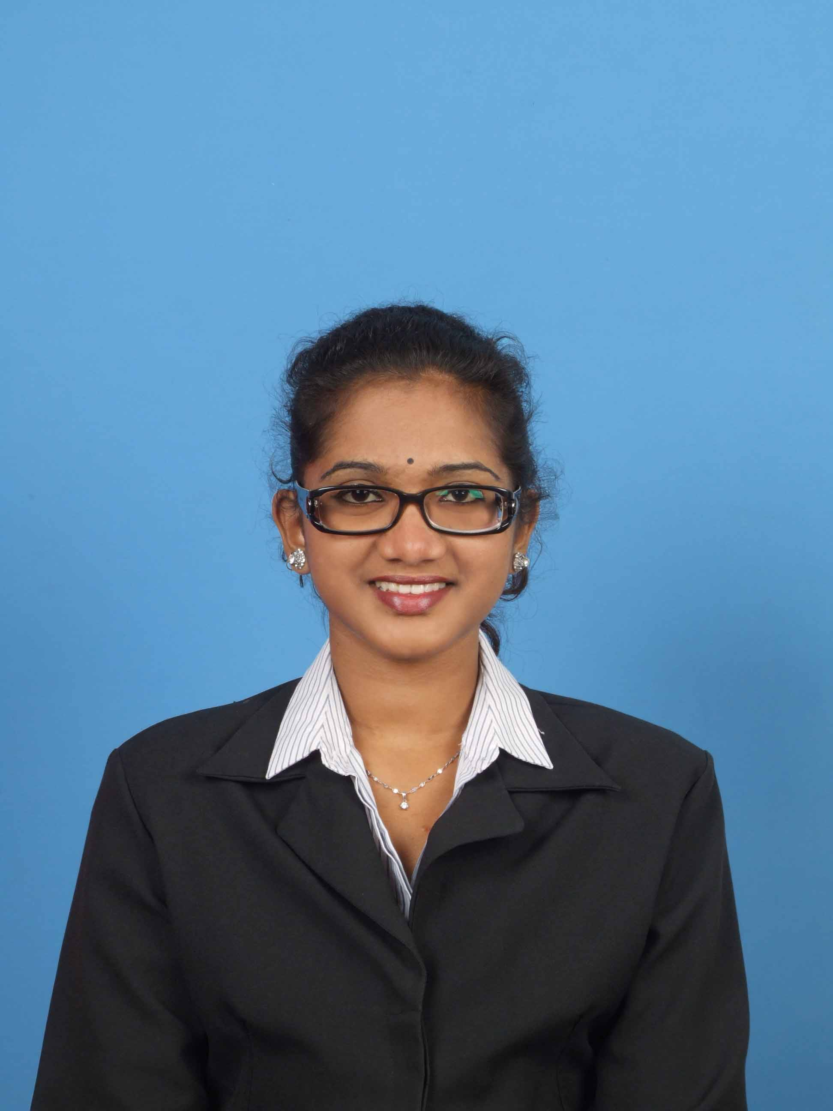

To be an innovative and vibrant employee by utilizing my knowledge, experience and interpersonal skills. Concurrently, be able to contribute positively according to the mission of the organization.

Gautamii a/p Balu

Name: :Gautamii a/p Balu
Permanent Address : No C-7-7, Angkasa Condominium,
Jalan Puncak Gading,
Taman Connaught,
56000 Cheras, Kuala Lumpur .
E-Mail : gautamii_balu@yahoo.com
Telephone (Mobile) : 016-4443379
IC. Number : 891115-08-6388
Date of Birth : 15/11/1989
Age : 25
Nationality : MALAYSIAN
Race : INDIAN
Religion : HINDU
Marital Status : SINGLE
Gender : FEMALE
Height : (165cm)
Weight : 56kg

YEAR COLLEGE COURSE
2010 PTPL Shah Alam Dip Hotel Management
2008 PTPL Shah Alam Certificate Hotel Management
2006 Convent Teluk Intan SPM

WORK EXPERIENCE
Currently  Pkf Covenant Equity Consulting Sdn Bhd  Level 33, menara 1MK,  Kompleks 1 Mont Kiara,  No 1 Jalan Kiara Mont Kiara  50480 Kuala Lumpur  Tel : 03 -62031888  Position: Admin clerk and Receptionist  August 2012 – July 2013  Chartis  Enterprise 1, Technology Park Malaysia,  Bukit jalil,57000 Kuala Lumpur  Tel: 03-27196000  Position: HR Advisor  April 2012 – July 2012  Cititel hotel, Mid Valley  Position: Trainee | Work Done and Responsibilities  - Managing staff claims and staff documentation.  - As well answering all incoming calls  Work Done and Responsibilities  ● Human resources management  Work Done and Responsibilities  ● Finance department: Handle payment & invoices  ● Marketing department: Send quotation to clients  ● Purchasing department: Informing orders to relevant company

May 2010 – April 2012  Pizza Hut, Cheras  Position: Crew services & Cashier  July 2009 – December 2009  Concord hotel, Shah Alam  Position: Trainee | Work Done and Responsibilities  ● In charge of the services at pizza outlet, served food, attend to customers enquiries and being a cashier  Work Done and Responsibilities  ● Worked as call centre officer to handle calls  related to inbound and outbound hotel  enquiries  ● Worked at the front office and in charge of  customer’s the check in check out and  room reservations

LANGUAGE LITERACY

LANGUAGE WRITTEN SPOKEN
Bahasa Melayu Good Good
English Good Good
Tamil Average Good

REFERENCES

Miss Azizah, (Lecturer) = 017-6206296
Zul, (ManagerPizza Hut) = 017-235537
Terrence, (AIG Team Leader) = 016-66105410
Sharifah ,( PKF Team Leader ) = 016- 2147287

